Religion thematic keywords: sin, grace, judgement, heaven, hell, death, resurrection, salvation

Progress of ideas
Headings. Understanding how scribes derived or determined headings. Is it based on genre, on attribution, on concept, based content (e.g. first line), etc. More quantitatively, degree of variance from the norm in the titles of any given poem, and then looking at the scores to determine whether some scribes exercised more or less agency in their determination of titles.
Sentiment analysis based on titles, headings, first and last lines, and how these are distributed across scribes/mss etc. Question: would we want to strip generic categories such as sonnet and, more to the point, elegy. Modulate into (after conversation with AI John) …
Vector based semantic analysis using embedded data. Concatenating embedded data in heading/title and first/second/penultimate/last lines. Grouping data for items in a manuscript to identify the DNA of a collection as a reflection of that collector’s interests, preferences, tendencies—the topical composition of the collection. Then, compare all manuscript collection to identify similar and difference between collections in terms of their topical composition expressed as graphs.
The thing we are testing is how these collections reflect their collectors: their interests, preferences, tendencies and how similar and different these collections are in their composition. What is the range of profiles of these collectors? And how diverse are these collections (and the collectors they represent)?

The Data
We recognize that there are limitations in our data. Semantic content is limited to titles (which we take to be mostly but not reliably constructs of the cataloguers) and headings (which we take to be mostly but not reliably derived from the artefacts themselves) and to first lines (present for almost all entries—save only about 7,000) as well as last lines (far fewer, about 10,000) and second and penultimate lines (fewer yet). 7,000 entries have no data for any of these fields.
The headings are not consistently only what is in the artefact (in some cases it is actual cataloguer description); and the title is often a repeat of what is in the heading field. To reduce redundancy, we will use title information for entries with no heading and then delete the rest of the title information. Many of the titles/headings include personal names (e.g. in the case of verse letters or commendatory poems). These might be a problem for sentiment analysis (e.g. in cases where “Brown” is a personal name but could also be a colour): it might be that the vectored data makes that distinction (We aren’t sure). The same time, inclusion of personal names are valuable markers of content.

Process
First, we will try visualizing the whole dataset. If that proves unwieldy, we will select only the most important manuscript miscellanies that include Donne.
We identified the thirty early modern manuscripts with the largest number of poems (by any author whatsoever) and created text files listing each manuscript’s contents by author name. We then removed manuscripts that are essentially single-author collections. These included, for example, manuscripts that are in their entirety George Herbert’s The Temple (Bodleian Library MS Tanner 14 and Harvard University MS Eng 1544). We include, however, Harvard University MS Eng 966.3, which includes one poem by Richard Corbett in a collection that otherwise contains only poems by Donne; and Harvard University MS Eng 966.3, which is almost entirely poems by Donne but has one poem each by John Hoskyns and George Herbert and two by Ben Jonson. This left us with content lists of nineteen manuscripts.

First batch attempt
Oxford Rawl. poet. 218 not in Beal because it is entirely poems by a non-canonical writer Robert Robinson (fl. 1660).
Folger MS v.b.370 a “miscellany” (Folger) not in CELM because its authors are anonymous, except for one poem by Queen Elizabeth.
Leeds University LibraryLt.40 entirely poems by noncanonical writer Sir Philip Wodehouse
Yale Osborn MS fb 217
Autograph MS of ten books of epigrams by Sir Thomas Urchard. https://celm.folger.edu/repositories/yale-osborn-collection-other.html

Results
Although this is not a reliable visualization (because it represents in two dimension a vector that has 300 dimensions) it nonetheless presents a phenomenon that correlates to our statistical model below–namely, that Yale Osborn MS fb 217 is an outliner, being a collection entirely of one genre.
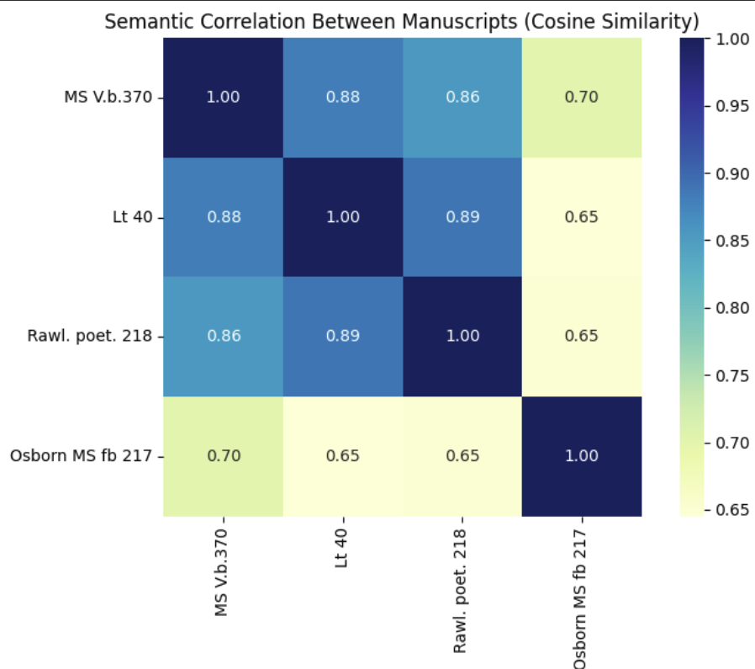

Thematic analysis
Across all the data. Asked GT to produce top ten themes.
Created a thematic cluster to test degrees of religious content in poems: sin, grace, judgement, heaven, hell, death, resurrection, salvation

Miscellanies
We then tried only four and then nine of the top manuscript collections
Notices a cluster of red that turn out to be all Psalms:
200990 Psalm 114
204977 Psalm 104
205255 Psalm 1
Chose:
- Aberdeen University Library, MS 29
- British Library, Add. MS 25707
- British Library, Add. MS 30982
- Bodleian, MS Ashmole 38
- Folger, MS V.a.170
- Folger, MS V.a.97
- University of Nottingham, Pw V 37

Choice MS miscellanies
Aberdeenms29 = Aberdeen University Library, MS 29
BLAdd25707 = British Library, Add. MS 25707
BLAdd30982 = British Library, Add. MS 30982
BLHarley4955 = British Library, Harley MS 4955
BLStowe962 = British Library, Stowe MS 962
BLTanner465 = Bodleian, MS Tanner 465
BodlAshmole38 = Bodleian, MS Ashmole 38
BodlEngpoetc50 = Bodleian, MS Eng. poet. c. 50
BodlEngpoetf9 = Bodleian, MS Eng. poet. f. 9
CambAdd8468 = Cambridge University Library, MS Add. 8468
CCOxMS325 = Corpus Christi College, Oxford, MS 325
FolgerVa170 = Folger, MS V.a.170
FolgerVa97 = Folger, MS V.a.97
HarvEngMS966pt3 = Harvard, MS Eng 966.3
HarvEngMS966pt5 = Harvard, MS Eng 966.5
HuntHM198pt1 = Huntington, HM 198, Part I
NottPwV37 = University of Nottingham, Pw V 37
RosenMS1083sl17 = Rosenbach Museum & Library, MS 1083/17
RosenMS239sl27 = Rosenbach Museum & Library, MS 239/27

